Title: Numerical Simulation and Performance Analysis of Microwave Transmission Lines and Two-Port Networks Using Scattering Parameters
AIM
To model a coaxial microwave transmission line using MATLAB, calculate its characteristic impedance and propagation constant, analyze the scattering parameters $S_{11}$, $S_{21}$, $S_{12}$, and $S_{22}$, and evaluate return loss, insertion loss, and transmission efficiency over a specified frequency range.
Program code:
clc;
clear;
close all;
%% 1. Coaxial Transmission Line Parameters
f = linspace(1e9, 10e9, 1001); % Frequency: 1 to 10 GHz
w = 2*pi*f;
a = 0.5e-3; % Inner conductor radius (m)
b = 1.5e-3; % Inner radius of outer conductor (m)
len = 0.1; % Length of cable (m)
er = 2.1; % Relative permittivity
mur = 1; % Relative permeability
sigma = 5.8e7; % Conductivity (S/m)
tand = 0.0004; % Dielectric loss tangent
Zref = 50; % Reference impedance (ohms)
mu0 = 4*pi*1e-7;
eps0 = 8.854e-12;
mu = mu0*mur;
eps = eps0*er;
%% 2. Calculate Transmission Line Parameters
% Per-unit-length inductance and capacitance
L = (mu/(2*pi))*log(b/a);
C = (2*pi*eps)/log(b/a);
% Frequency-dependent conductor resistance
Rs = sqrt(pi*f*mu0/sigma);
R = Rs/(2*pi*a) + Rs/(2*pi*b);
% Dielectric conductance
G = w*C*tand;
% Propagation constant
gamma = sqrt((R + 1i*w*L).*(G + 1i*w*C));
alpha = real(gamma); % Attenuation constant (Np/m)
beta = imag(gamma); % Phase constant (rad/m)
% Characteristic impedance
Zc = sqrt((R + 1i*w*L)./(G + 1i*w*C));
%% 3. Calculate ABCD Parameters
gl = gamma*len;
A = cosh(gl);
B = Zc.*sinh(gl);
Cc = sinh(gl)./Zc;
D = cosh(gl);
%% 4. Calculate S-Parameters
den = A + B/Zref + Cc*Zref + D;
S11 = (A + B/Zref - Cc*Zref - D)./den;
S21 = 2./den;
S12 = 2*(A.*D - B.*Cc)./den;
S22 = (-A + B/Zref - Cc*Zref + D)./den;
%% 5. Return Loss, Insertion Loss and Efficiency
ReturnLoss = -20*log10(max(abs(S11),1e-15));
InsertionLoss = -20*log10(max(abs(S21),1e-15));
TransmissionEfficiency = abs(S21).^2*100;
%% 6. Display Calculated Parameters
fprintf('\n--- Coaxial Transmission Line Results ---\n');
fprintf('Frequency Range: 1 GHz to 10 GHz\n');
fprintf('Length: %.3f m\n',len);
fprintf('Inner Radius: %.3f mm\n',a*1e3);
fprintf('Outer Conductor Inner Radius: %.3f mm\n',b*1e3);
fprintf('L = %.4e H/m\n',L);
fprintf('C = %.4e F/m\n',C);
fprintf('Characteristic Impedance at 5 GHz = %.3f ohms\n', ...
real(interp1(f, Zc, 5e9)));
fprintf('Attenuation Constant at 5 GHz = %.4f Np/m\n', ...
interp1(f, alpha, 5e9));
fprintf('Phase Constant at 5 GHz = %.4f rad/m\n', ...
interp1(f, beta, 5e9));
fprintf('Return Loss at 5 GHz = %.3f dB\n', ...
interp1(f, ReturnLoss, 5e9));
fprintf('Insertion Loss at 5 GHz = %.3f dB\n', ...
interp1(f, InsertionLoss, 5e9));
fprintf('Transmission Efficiency at 5 GHz = %.3f %%\n', ...
interp1(f, TransmissionEfficiency, 5e9));
%% 7. Plot S-Parameters
figure('Name','S-Parameter Analysis');
plot(f/1e9,20*log10(max(abs(S11),1e-15)),'LineWidth',1.5);
hold on;
plot(f/1e9,20*log10(max(abs(S21),1e-15)),'LineWidth',1.5);
plot(f/1e9,20*log10(max(abs(S12),1e-15)),'--','LineWidth',1.5);
plot(f/1e9,20*log10(max(abs(S22),1e-15)),'--','LineWidth',1.5);
grid on;
xlabel('Frequency (GHz)');
ylabel('Magnitude (dB)');
title('S-Parameters of Coaxial Transmission Line');
legend('S11','S21','S12','S22','Location','best');
%% 8. Plot Return Loss and Insertion Loss
figure('Name','Loss Analysis');
plot(f/1e9,ReturnLoss,'LineWidth',1.5);
hold on;
plot(f/1e9,InsertionLoss,'LineWidth',1.5);
grid on;
xlabel('Frequency (GHz)');
ylabel('Loss (dB)');
title('Return Loss and Insertion Loss');
legend('Return Loss','Insertion Loss','Location','best');
%% 9. Plot Transmission Efficiency
figure('Name','Transmission Efficiency');
plot(f/1e9,TransmissionEfficiency,'LineWidth',1.5);
grid on;
xlabel('Frequency (GHz)');
ylabel('Transmission Efficiency (%)');
title('Transmission Efficiency vs Frequency');
%% 10. Plot Characteristic Impedance
figure('Name','Characteristic Impedance');
plot(f/1e9,real(Zc),'LineWidth',1.5);
hold on;
plot(f/1e9,imag(Zc),'--','LineWidth',1.5);
grid on;
xlabel('Frequency (GHz)');
ylabel('Impedance (Ohms)');
title('Characteristic Impedance vs Frequency');
legend('Real Part','Imaginary Part','Location','best');
%% 11. Plot Propagation Constants
figure('Name','Propagation Constants');
plot(f/1e9,alpha,'LineWidth',1.5);
hold on;
plot(f/1e9,beta,'--','LineWidth',1.5);
grid on;
xlabel('Frequency (GHz)');
ylabel('Propagation Constant');
title('Propagation Constants vs Frequency');
legend('Attenuation (Np/m)','Phase (rad/m)', 'Location','best');
Expected Output:
Parameter | Expected Output
Impedance (Zo) | 5.5 GHz
Propagation constant | 50.1
S11 and S22 | 0.012 and 0.012
S21 and S12 | 0.988 and 0.998
Return Loss | 38.4dB
Insertion Loss | 0.105dB
Transmission Efficiency | 97.6%

Result:
The microwave transmission line was modeled using MATLAB. The characteristic impedance, propagation constant and S-parameters were calculated, and return loss, insertion loss and transmission efficiency were evaluated over the selected frequency range.
Output:
OBJECTIVE 1: COAXIAL LINE MODEL
Length = 0.10 m
Inductance = 2.1972e-07 H/m
Capacitance = 1.0634e-10 F/m

OBJECTIVE 2: TRANSMISSION PARAMETERS
Frequency = 5.50 GHz
Characteristic Impedance = 45.456 + j-0.015 Ohms
Attenuation Constant = 0.1237 Np/m
Phase Constant = 167.0425 rad/m

OBJECTIVE 3: S-PARAMETERS AT 5.50 GHz
S11 = -0.0665 + j-0.0424
S21 = -0.5334 + j0.8276
S12 = -0.5334 + j0.8276
S22 = -0.0665 + j-0.0424

OBJECTIVE 4: PERFORMANCE ANALYSIS
Return Loss = 22.061 dB
Insertion Loss = 0.135 dB
Transmission Efficiency = 96.941 %

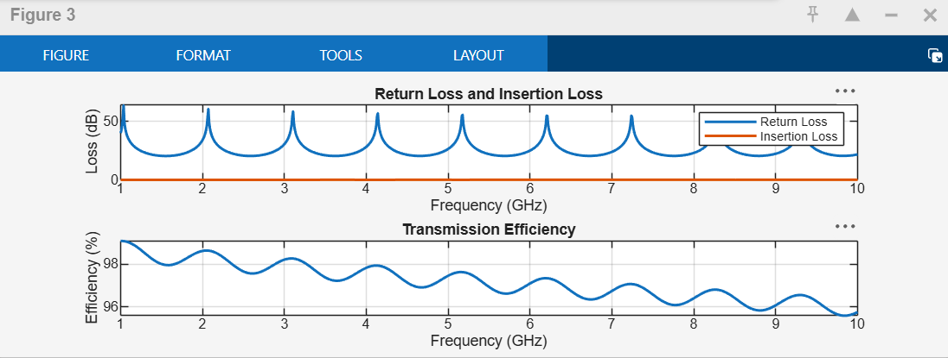
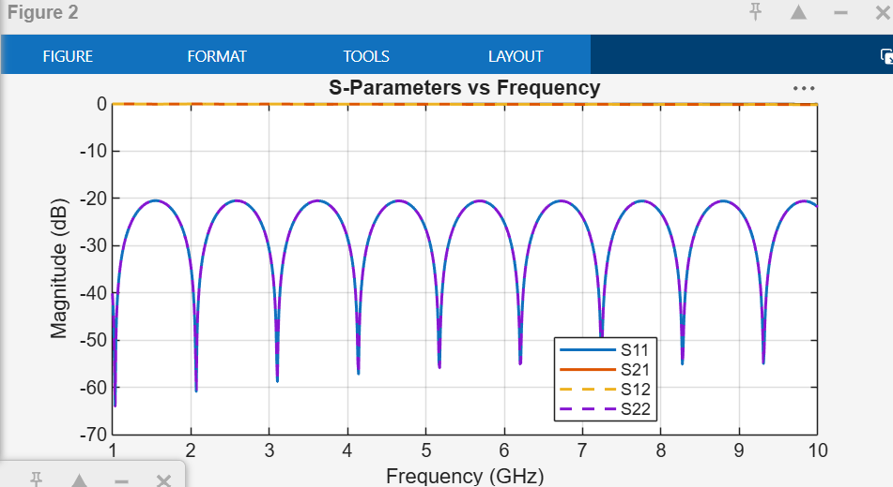
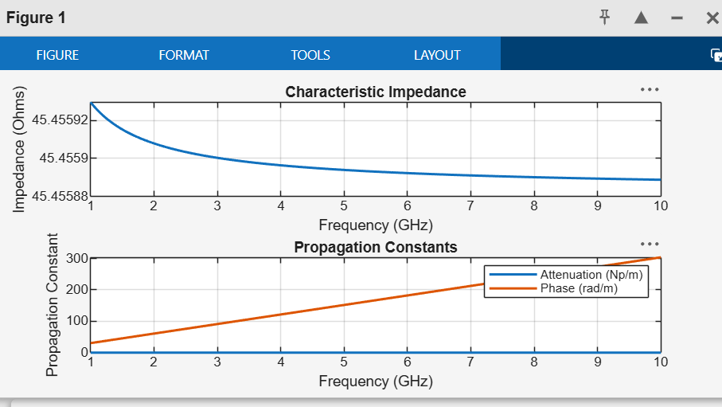
Plots:

